**Pong: An Examination of Action-Specific Perceptual Effects with Minimized Confounds of Memory and Task-Demand**

Lindsey Sample, David Schwitzgebel, Eliana Rich, Josh Carreras, & Nanak Nihal Khalsa

Submitted April 28, 2019

Vassar College

**Introduction**

Has time ever seemed to move in slow motion? Perhaps, during an intense moment of a basketball game, you experienced a vivid slowdown in the motion of the world. Has time ever seemed to speed out of control? Perhaps, during a difficult exam, you experienced time slipping away like sand through your fingers. The present study aims to explore this phenomenon: can the difficulty of a task influence our perception of time and speed? More broadly, we are interested in exploring whether cognition can directly impact perception. This kind of phenomenon is called a “top-down effect.” Several researchers have come to criticize extant research, claiming that we have yet to identify any cases in which cognition has a true, direct effect on perception (Firestone & Scholl, 2016). Thus, by exploring this specific issue (the effect of task difficulty on time and speed perception), we hope to contribute to the broader understanding of the relationship between cognition and perception.

*Top-Down Effects and Action-Specific Cognition*. An abundance of previous research has explored possible links between task difficulty, performance, and perception. Witt & Proffitt (2005) found that softball players with better batting performance tended to report seeing the ball as larger than players with poorer batting performance. In a task where participants were asked to drop darts onto a target, participants took fewer attempts to hit the target when they reported perceiving the target as larger, even though the actual size and distance of the target remained the same (Canal-Bruland Canal-Bruland R, Kamp J van der., 2010; Wesp R, Cichello P, Grazia E B, Davis K., 2004). Witt, et. al. (2008) found that participants asked to make a simple golf putt reported perceiving the hole as larger than those asked to make a more difficult putt. These studies all fall under the umbrella of “action-specific perception,” which claims that our ability to perform specific actions directly affects how we perceive elements of our environment involved in those actions (Witt & Sugovic, 2010; Witt, 2011). Witt and Sugovic (2010) examined this phenomenon, exploring possible top-down effects on speed perception in tennis and pong. In the pong-based experiment, they found that when the paddle size was smaller, participants reported that the ball was moving faster. In this study, participants were trained to recognize “slow” and “fast” speeds and were asked after each trial whether the ball’s speed seemed closer to either the “slow” or “fast” speed. Participants played all of the “games” (i.e., trials) with a paddle of three possible size variations - small, medium, or large. The researchers found that as the paddle size decreased participants were more likely to report the ball as moving closer to the “fast” speed than the “slow” speed. Witt & Sugovic (2010) claimed that a participant’s perception of time was directly influenced by the actions involved in the task of playing the game, resulting in a time “speed-up” as the game grew more difficult. Presently, we are attempting to improve upon their methodology to examine the same effect in a pong game.

*Validity of Research in Question*. The existing body of research discussed has claimed that “perception is a function of the perceiver’s abilities” (Witt, 2011). This falls into the general category of top-down effects. According to the action-specific perception account, higher-level cognition (i.e., how difficult we believe a task is, our ability/skill to perform that task, etc.) can directly influence lower-level perception of objects or experiences. However, extant research into action-specific perception research is flawed, and it is uncertain whether it demonstrates *true* top-down effects, or whether the top-down effects that it claims to demonstrate are conflated by the influences of confounding factors (Firestone & Scholl, 2016). Attention has been drawn to the validity of these studies and experimental flaws that call into question top-down findings. Firestone and Scholl (2016), in their criticism of research involving top-down effects, outline several “pitfalls” that have the potential to compromise the integrity of findings. One of our motivations for choosing to build upon the work of Witt and Sugovic (2010) in the present study is to determine whether the effect still holds once we eliminate the pitfalls that plagued their study. We specifically address the pitfalls of memory confluence and task demand.

*Memory Pitfall Elimination*. According to Firestone & Scholl’s (2016) pitfall of memory, if participants are asked to recall a perceptual experience, their reports may not be consistent with their actual perceptual experiences. Memories distort even over a brief period of time, and any after-the-fact account cannot be treated as reliable. Further, memory is an element of higher-level cognition and cannot be treated as equivalent to lower-level online perception. Thus, studies claiming to have found top-down effects that rely on participants’ reported recollections of perceptions may not have found a true top-down effect  (i.e., a direct effect on perception from cognition) and, rather, may have identified an indirect effect of memory on perceptual recall. Much of the research that targets action-specific perception incorporates this pitfall, and Witt & Sugovic’s (2010) study is no exception. Witt and Sugovic (2010) fall into the memory pitfall in two respects. First, they ask participants to memorize “fast” and “slow” speeds in advance, then ask participants to compare the trial balls’ speeds to those memorized speeds. Furthermore, they ask participants to make this judgment *after* the trials are complete– thus, relying on participants’ memory of motion, rather than on their online experience of motion. In essence, they are asking participants to compare a memory (of the trial ball’s speed) to another memory (of the preset fast and slow speeds).

In our attempt to eliminate the confounding pitfall of memory, unlike the Witt and Sugovic (2010) study, we do not ask participants to report their perception of the ball’s speed after the fact. Further, we do not ask participants to memorize preset speed comparisons in advance. Rather, we ask participants to report their real-time, moment-to-moment perceptual experiences. Specifically, in each trial, we ask participants whether the target ball is moving at the same speed, faster, or slower than a background ball. We ask participants to respond during the trial, rather than afterthe trial, in order to help eliminate the possible confound of memory. The target ball is hit by the player paddle and contributes to their score in each trial. The background ball bounces in the background, has no bearing on the game or score, and simply serves as a reference for speed, which is utilized when we ask participants to guess which ball is moving faster (target or background), or if they are moving the same speed. Critically, the target ball and background ball will always be moving at the same speed. According to the action-specific perception hypothesis, the target ball should appear to be moving faster than the passive ball when the paddle size is small, due to the top-down influence that the task has on participants’ perception. Attempting to hit the target ball with a small paddle constitutes a challenging task, while the background ball is moving in the background irrespective to the task and should not be subject to any top-down perceptual influence. Specifically, we hypothesize that participants will tend to report that the target ball is moving at a different speed than the background ball given different paddle size conditions, despite the fact that they will always be moving at the same speed. Thus, in our study, any effect that the participants demonstrate (i.e., if they tend to report that the target ball is moving faster than the background ball when the paddle is smaller) will be due to an online processing effect rather than a memory effect.

*Task Demand Confound Eliminated.* The pitfall of task demand, as outlined in Firestone & Scholl’s 2016 work, is a participant’s relationship with the nature of an experimental task and the potential confounding effect this may have on perception. For instance, if a participant guesses the hypothesis of an experiment, it may bias their answers towards the hypothesis. In this case, any effects demonstrated by this experiment may be a product of the bias introduced by task demand rather than a true top-down effect. Further, task demand can introduce subtler confounds; Firestone and Scholl (2016) specifically identify a possible task demand impact on the results of the study performed by Witt and Sugovic (2010). They note that previous research has found that participants are prone to blaming equipment to excuse poor performance in more challenging tasks (Wesp et al. 2004; Wesp & Gasper 2012) and propose that this study may be falling prey to a similar confound: participants may be claiming that the ball is moving faster to account for their struggle to hit it rather than truly perceiving the ball as moving faster. Further, they note that participants should be asked about their theories concerning the study’s hypothesis, such that it is clear whether or not hypothesis guessing (as noted earlier) may be confounding results.

We attempt to minimize the possible impact of task demand by asking participants to report a self-assessment of their performance on a sliding scale. If the effect persists even if participants report a positive self-assessment (i.e., if they believed that they did well), then the task demand effect is not a confound. However, if the effect only reliably manifests in cases where the participant reports a negative self-assessment, then task demand (rather than a top-down perceptual effect) may have caused participants to demonstrate the effect. Furthermore, we will ask participants what they believed the purpose of the study was in order to account for any biases that may have been introduced due to participants’ awareness of the study’s specific hypotheses. We did not ask filler questions to cover up our hypothesis such as “which ball is your favorite” which we had originally discussed in our pre-registered OSF report (<https://osf.io/mv9kq>).

*Hypothesis*. We are expecting to see a change in participants’ reported relative ball speed (i.e., target ball compared to the background ball) based on the variable of paddle size (small, medium, or large). In other words, we predict that participants will be more likely to report that the target ball is a moving faster or slower than the background ball as the paddle size changes.

**Methods**

Fifty participants were recruited over the internet via Prolific. Each participant completed a roughly 12-minute session and was compensated $2. During this trial, they completed 45 mini-games of pong, plus 3 practice rounds (total 48 mini-games), which involved using the cursor to move a paddle up and down on the screen to hit a moving ball. The full experiment is available at <https://github.com/nkhalsa/top-down-pong>.

We had 2 factors each with 3 levels: 3 paddle sizes (small, baseline and large) and 3 absolute speeds (slow, moderate and fast) at which both balls would move. There were 9 conditions (each paddle size with each absolute speed) and each participant completed 5 trials of each condition. Each trial lasted roughly 15s each. The trial durations were determined by number of bounces to the player’s side of the screen or paddle so that the trials would always end when the top-down effect should be most present. In order to ensure that every trial was roughly 15 seconds long, the number of hits per trial was based on the ball speed. For the fast speed, the trial lasted for 10 hits; for the medium speed, 8 hits; for the slow speed, 7 hits.

Targets were labeled in the first two seconds of each trial, and the targets were different colors than the background balls. This allowed the targets to be easily identified. Colors were chosen to have similar lightness, contrast with background, saturation, and hues with similar speed perception (according to previous research that suggests some colors are perceived as moving faster than others), in order to avoid effects of color on speed (Cavanagh, Tyler, & Favreau, 1984; Stone & Thompson, 1992). Target-distractor color pairs were excluded before the experiment if a human judge found them to be moving at different speeds when their actual speeds were identical. Color pairs were also excluded that may be indistinguishable to those with deuteranopia (color blindness). For each trial, a color pair was selected with an equiprobability of either color being assigned to either of the balls.

Participants began with 3 practice rounds (baseline paddle, slow speed) in the beginning, during which they practiced the multi-tasking element of the task, which involved answering a question about ball speed using the ‘1’, ‘2,’ and ‘3’ keys. Participants were asked to compare the speed of the target ball to the ball moving in the background, and to press 1 if the target ball was faster, 2 if the background ball was faster, and 3 if neither ball was moving faster relative to one another (which differs from our OSF pre-registered report). As noted earlier, both balls always moved at the same speed relative to one another, and any difference noted by participants reflected their perceptions rather than actual differences in speed. They were asked to press the number following a visual cue during the pong game. This cue appeared halfway through the trial (halfway through total hits, about 7.5s in).

After each trial, participants were asked to rank how well they think they did on a slider from “One of my best runs” to “One of my worst.” They were also asked to estimate the duration of the trial (clicking 10s, 15s or 20s) . After all trials were complete, participants were asked what they believed the hypothesis was as a free response. Participants were not informed of the trial lengths and were not informed that the game ball and background ball were always moving the same speed.

**Data Analysis**

Our original data analysis plan can be accessed in our pre-registered OSF report. The following is an account of the tests that came to fruition in this report. In order to test our primary hypothesis, we utilized an ordinal logistic regression. Paddle sizes were be treated as the primary manipulation, and participants’ reported perception of relative ball speeds was treated as the primary dependent variable. We coded the paddle sizes as interval variables from 1-3: the “small” paddle size was coded as 1, the “medium” paddle size was coded as 2, and the “large” paddle size was coded as 3. We treated participants’ reported perception of relative ball speed as ordinal data with three outcome types: “target-slower,” “target-equal,” and “target-faster,” based on whether participants responded that the target ball was moving faster, the balls were moving same speed, or the background ball was faster. We accounted for differences from subject to subject (i.e., biases towards answering “faster,” etc.) by treating subject-specific differences as a random effect.

Since our results for this main test were not significant, the follow-up tests mentioned in our pre-registered report were not necessary. However, we elected to include a few exploratory results to inform further research questions that might arise from our results. We utilized logistic ordinal regressions to examine the effect of absolute speed on guess (guessing if the target ball was moving faster, the background ball was moving faster, or the balls were moving the same speed), and paddle size on perceived duration of the study (responses were either 10s, 15s, or 20s). We also conducted two ANOVAs to examine whether paddle size or absolute speed effected score (calculated as human score – AI score). Finally, we included a paired t-test to examine the impact of task demand according to Firestone and Scholl’s criticism which compared self-reported game play efficacy (how well participants believed they did) to guess (relative ball speed response). A link to the annotated R notebook can be found on the OSF project registration (<https://osf.io/zxbhk/>).

**Results**

*Guess by Paddle Size.* Did the size of the paddle (small, medium, large) influence the relative ball speed (guess) according to the response of participants? Our analysis of a logistic ordinal regression did not yield a significant effect of paddle size on guess (*B=* -1.117, t(1306)=1.621, p=0.105). Our data reflects that in each paddle condition, participants most frequently responded that both the target and background ball were moving the same speed (which they, in fact, were). In the smallest paddle condition (the most difficult condition), participants responded more than in other conditions that the target was moving faster than the background ball. Participants were always more likely to guess that balls were moving the same speed or that the target was moving faster than to guess that the target was moving slower, relative to the background ball. We did not analyze this effect excluding participants since the effect was not significant without exclusion.

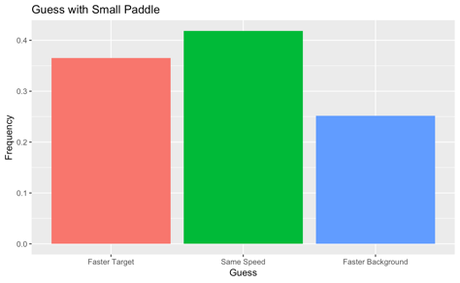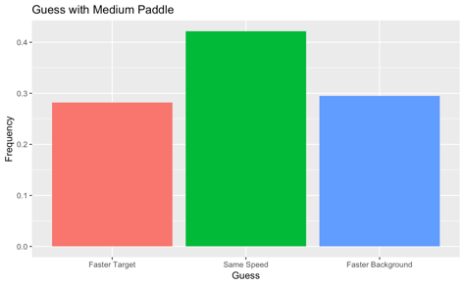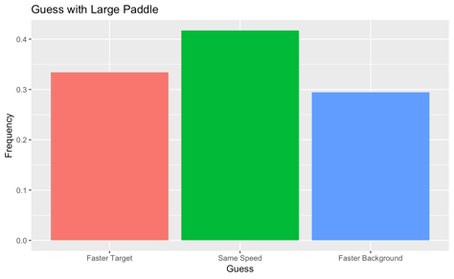

**Fig 1.**  Guess by paddle size.

*Exploratory Analysis: Guess by Absolute Speed.* We examined the effect of absolute speed (both the target and background ball moving at a fast, moderate or slow speed, simultaneously) on participant’s relative ball speed response (guess). Using a logistic ordinal regression, we found a significant effect of absolute speed on guess (*B*= -0.07533, t(1306)=-2.529, p=0.011). This demonstrates that when speed increased, participants were more likely to respond that the target ball was moving faster. We witnessed that participants were more likely to respond that the balls were moving the same speed in the slow and moderate speed conditions, but in the fast speed condition, respond that the target ball was moving faster than the background ball. Since this result was significant, we examined this result excluding the participants (n=4) who guessed the hypothesis and found that the effect of absolute guess on speed was still significant (*B=* -0.9717, t(1192)=-2.161, p=0.0306), implying that the Firestone and Scholl (2016) pitfall of task-demand was not responsible for the significant effect, and that guessing the hypothesis and responding with bias was not the reason that guesses were significantly towards the target ball moving faster as absolute speed increased.

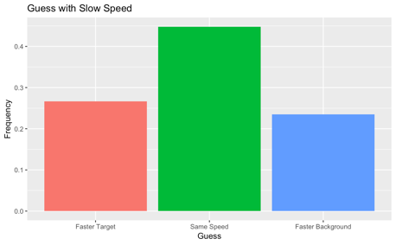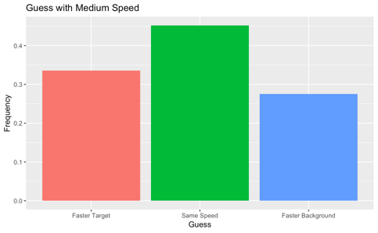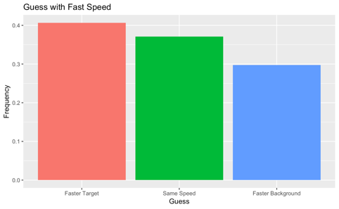

**Fig. 2.** Guess by absolute speed.

*Exploratory Analysis: Duration Perception by Paddle Size.* We examined whether paddle size influenced reported trial duration (participants could select 10s, 15s or 20s). We found that trial duration perception was not significantly effected by paddle size (*B*= 1.3798*,* t(1499)=-0.169, p=0.865).

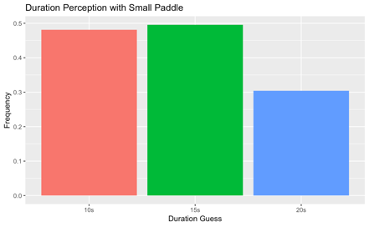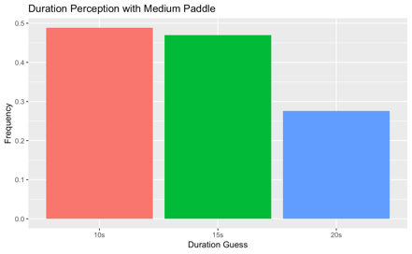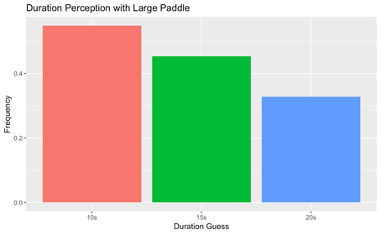

**Fig 3**. Duration of trial perception by paddle size

*Exploratory Analysis: Effect of Task Demand*. Using a paired t-test, we examined participant responses on how well they believe they performed in each trial to see if it had an effect on relative ball speed guess. We did not see a significant effect of self-report game play rating on relative ball speed guess (t(45)=-0.125, p=0.9006). Thus, we did not see an influence of Firestone & Scholl’s (2016) predicted influence of task-demand, where, in this case, participants would be theoretically influenced by believing they performed poorly and compensated for this by a biased response to the guess question to excuse their performance.

*Exploratory Analysis: Effect of Paddle Size on Score.* We investigated the influence of paddle size on score using an ANOVA. We found a significant effect of paddle size on score (F(2, 98)= 48.208, p= 2.642-15, p< 0.01), so we can infer that paddle size did effectively increase difficulty in the game (resulting in lower scores).

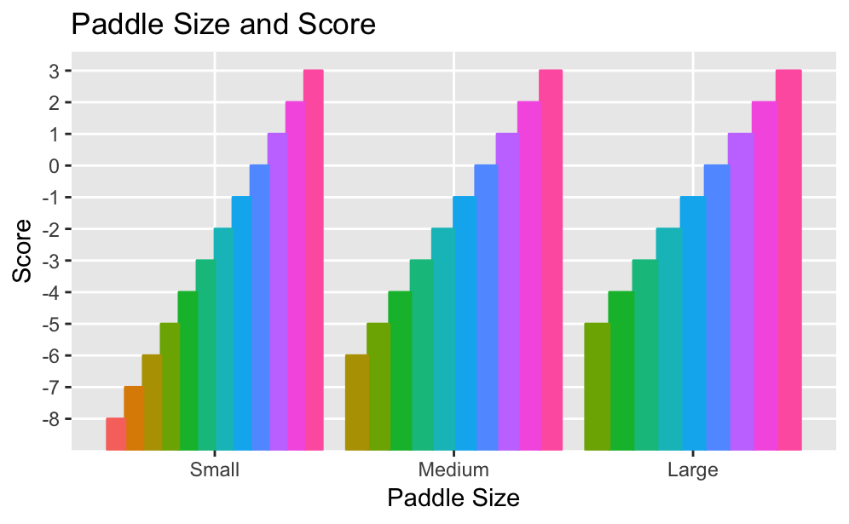

**Fig. 4.** Paddle Size and Score

*Exploratory Analysis: Effect of Speed on Score.* To see if absolute speed influenced score, we used an ANOVA to examine these factors. We found that speed did not influence score (F(2, 98)=0.995, p=0.373), so we can infer that speed did not significantly alter difficulty of the game.

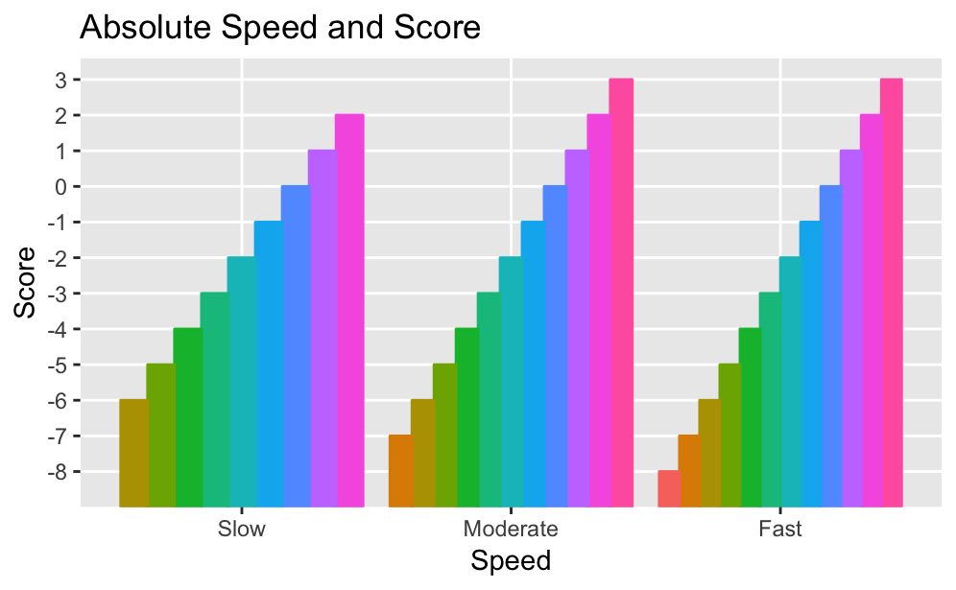

**Fig. 5.** Absolute Speed and Score

**Discussion**

Our main test yielded an insignificant result, which leads us to believe that when removing the pitfalls accounted for in the present study (memory and task demand), the phenomenon of action-specific speed perception does not occur. However, our exploratory analysis of the effect of absolute speed on guess leads us to believe that perhaps we began by asking the wrong question. We attempted to study the phenomenon of action specific top-down perceptual change in the context of a game, where when participants were focused on* a difficult game, they might perceive the game ball to be going faster (*focused on, attended to, underwent stress, or whatever mechanism results in altered speed perception. We did not claim to explain or prove which mechanism resulted in this effect, only that the effect exists). We manipulated game difficulty by changing paddle size, when, our results suggest, we should have considered both paddle size and absolute speed to be factors influencing difficulty, rather than focusing on paddle size in our analysis plan. However, strangely enough, we only saw a significant effect of paddle size on score, and saw that absolute speed did not significantly effect score, so, perhaps the difficulty of the game is not a factor in influencing action-specific perceptual effects, or contrarily, our measure of score did not effectively measure difficulty.

Additionally, one of the axioms of our study was that the target ball would be the only ball effected by the hypothesized action specific top-down effect, and that the background ball would not be effected. However, this is not a given. It is possible that the only ball effected would be the target, if the mechanism of the top-down effect was due to focusing on or attending to only the action at hand, but if the top-down effect occurred under stress, for example, all balls in the visual field would be effected.

Although our framework was a bit different than theirs, Witt and Sugovic (2010) forced participants to choose whether the ball was moving at a speed closer to the memorized “fast” or “slow” speed. In the present study, we framed our “guess” question a bit differently due to our attempt to eliminate the memory confound, and asked whether the target ball was moving faster, background ball was moving faster or they were moving the same speed. An important change from Witt and Sugovic (2010) that we introduced was including the option that the balls were moving the same speed, so participants could be “neutral” in their response, rather than in Witt and Sugovic (2010)’s design, participants had to choose between the faster/ slower binary. This could be another explanation for our insignificant effect. It is also possible that our phrasing biased participants. Unlike in a free response situation where participants could freely describe their perceptual experience, we are putting in the minds of participants the idea that the target ball is moving faster. This bias is mentioned by Firestone and Scholl (2016) and not accounted for in our study. It is worth mentioning that this bias is very difficult to eliminate under experimental conditions.

We asked our critical question in a way that differed from our original pre-registered report. We had planned to ask participants if the target ball was moving slower, the same speed, or faster than the background ball (a target comparison framework). We changed our phrasing due to miscommunication between the coding and planning parties within our team and time constraint. We asked participants if the target ball was moving faster, if the background ball was moving faster, or if neither was moving faster (a comparison between balls framework). This phrasing may seem trivial, but it is possible that the phrasing influenced guess.

We identified several points of concern within the realm of action-specific perceptual effects, but the most notable, perhaps, is determining the right environment of study with the right means of manipulation. Our main attempt to make the game more difficult was to change paddle size, when perhaps a better variable would have been absolute speed (according to our exploratory analysis on guess but not on score), but perhaps the issue lies with the fact that increasing *difficulty* might not be the best mechanism to elicit an action-specific perceptual effect. There are so many unknowns in the equation involving the mechanisms of action-specific perceptual effects (stress, time pressure, attending to specific objects, intrinsic pressure to win a game, focus, competitive-ness) witnessed in folk culture like sports games, and it is very difficult to emulate each aspect in an experimental setting, or to rule out the importance of any of these factors.

The present study does not attempt to prove that action-specific perceptual effects are an example of top-down effects, due to the complicated nature of top-down effects and the inability of behavioral data to confirm the neuroanatomical correlates of top-down processing. We were simply interested in replicating the effect proposed by Witt and Sugovic (2010) without several confounds regarding memory and task-demand. We found that the desired effect did not replicate when these confounds were removed. This could imply that Witt and Sugovic (2010)’s findings regarding action-specific perceptual effects are actually effects on memories of action-specific perception rather than live perception. However, in the end, our study differed greatly from Witt and Sugovic (2010), specifically in the format and phrasing of our critical question (relative ball speed guess), which arguably undermines our ability to credibly compare our findings to Witt and Sugovic (2010). Regardless, action-specific perception is a field sprinkled with complication and nuance that requires substantial creativity to test and many opportunities to take researcher degrees of freedom. Future research might be interested in examining the effect of different phrasing of questions in perceptual comparison tasks that are live, with a focus on avoiding the memory pitfall but without removing participants from the action that is intended to cause the effect. As we discovered in the present study, this is not an easy task. We struggled with this in our experimental design, and potentially overcomplicated our study by asking participants to press buttons while playing pong, which can result in less thoughtful responses due to stress and attentional selection. Accounting for experimental pitfalls, such as those outlined by Firestone and Scholl (2016) is important to upholding the efficacy of research science and worth considering in experimental design despite the accompanying costs (such as overcomplication). Future research might also be interested in answering the question: What informs action-specific perception? We believed this factor was difficulty, as manipulated by paddle size, but as discussed earlier, this is questionable in terms of how to manipulate difficulty, and whether or not difficulty is the right factor to be manipulating in the first place.

**Acknowledgements**

The research team would like to thank Professors Ken Livingston and Josh De Leew for their guidance on and contribution to this project.

**References**

Canal-Bruland R, Kamp J van der. (2010). Action goals influence action-specific perception. *Psychonomic Bulletin & Review*, *16*, 1100 - 1105

Cavanagh, P., Tyler, C. W., & Favreau, O. E. (1984). Perceived velocity of moving chromatic gratings. *Journal of the Optical Society of America A,1*(8), 893.

Firestone, Chaz, & Brian J. Scholl. (2016). “Cognition Does Not Affect Perception: Evaluating the Evidence for ‘Top-down’ Effects.” *Behavioral and Brain Sciences*, vol. 39, 2016.

Stone, L. S., & Thompson, P. (1992). Human speed perception is contrast dependent. *Vision Research, 32*(8), 1535-1549.

Wesp R, Cichello P, Grazia E B, Davis K. (2004). Observing and engaging in purposeful actions with objects influences estimates of their size. *Perception & Psychophysics,* *66*, 1261- 1267

Witt J K. (2011). Action's effect on perception. *Current Directions in Psychological Science, 20, 201 - 206*

Witt J K, Linkenauger S A, Bakdash J Z, Proffitt D R. (2008). Putting to a bigger hole: Golf performance relates to perceived size.' *Psychonomic Bulletin & Review, 15*, 581-585

Witt J K, Proffitt D R. (2005) See the ball, hit the ball: Apparent ball size is correlated with batting average. *Psychological Science*, *16*, 937 - 938

Witt, J. K., & Sugovic, M. (2010). Performance and Ease Influence Perceived Speed. *Perception*, *39*(10), 1341–1353.